AUTOMATED NETWORK
REQUEST MANAGEMENT
Professional Project Documentation

PROJECT | Automated Network Request Management
PLATFORM | ServiceNow
USER INTERFACE | Service Portal
WORKFLOW | Catalog → Request Records → Approval → Network Task → Status → Notification
DOCUMENT TYPE | ServiceNow Custom Application Report

Prepared from the supplied project documentation and implementation screenshots.

Table of Contents
- 1. Executive Summary
- 2. Project Overview
- 3. Problem Statement and Objectives
- 4. Application and Data Architecture
- 5. Requirement Analysis and Planning
- 6. Catalog Item and Variable Configuration
- 7. Service Portal Interface and Usability
- 8. Flow Designer Automation
- 9. Approvals and Network Task Management
- 10. Business Rules, UI Policies, and Access Control
- 11. Notifications and Status Tracking
- 12. End-to-End Functional Workflow
- 13. Testing and Validation
- 14. Deployment and Configuration Management
- 15. Conclusion and Future Enhancements

1. Executive Summary
The Automated Network Request Management application is a ServiceNow-based solution designed to provide a structured process for submitting, reviewing, approving, and fulfilling network-related service requests.
The documented implementation uses the Service Catalog and Service Portal to capture requests, Flow Designer to coordinate workflow activities, custom tables to maintain application records, approvals to support authorization, Network Tasks to coordinate fulfilment, and notifications to communicate progress.
The intended outcome is a centralized request lifecycle with clearer ownership, improved traceability, and reduced reliance on unstructured request channels.

2. Project Overview
The project provides a centralized mechanism for users to submit network-related requests through a Network Request Catalog Item. The submitted information is captured through structured catalog variables, and the Requested For field is configured to populate automatically with the current user.
After submission, ServiceNow creates the standard Request and Requested Item records. The Flow Designer workflow then creates a Network Database record, initiates approval, and supports Network Task creation when approval is granted. Status updates and email notifications help keep relevant users informed.

Key capabilities
- Submit network requests through the Service Portal.
- Capture request information through structured catalog variables.
- Populate the Requested For field with the current user.
- Create and maintain Request and Requested Item records.
- Create a Network Database record through Flow Designer.
- Route the request for approval and create a Network Task after approval.
- Communicate important progress updates through notifications.

3. Problem Statement and Objectives

Problem statement
Network service requests can become difficult to manage when they are submitted through informal or unstructured channels. Such channels can make it harder to collect complete information, route requests consistently, monitor approval decisions, and communicate fulfilment progress.
This project addresses that challenge by implementing a controlled ServiceNow workflow for request submission, information capture, approval, task creation, status tracking, and notifications.

Project objectives
- Provide a centralized Network Request Catalog Item.
- Capture complete request details using structured catalog variables.
- Automate approval routing and Network Task creation.
- Maintain request progress through status updates.
- Notify relevant users about important request events.
- Use access controls and Update Sets to support controlled administration and configuration management.

4. Application and Data Architecture
The application is implemented on the ServiceNow platform and combines the Service Catalog, Service Portal, custom application tables, Flow Designer, approval records, access controls, and notifications.

High-level request lifecycle
Catalog Item → Request → Requested Item → Network Database → Approval → Network Task → Status Update → Notification

Core components
Component | Responsibility
Service Catalog | Provides the Network Request Catalog Item for request submission.
Catalog Variables | Capture the information required to process a network request.
Request / Requested Item | Represent the standard ServiceNow request and requested-item records.
Network Database | Stores the project-specific network request information.
Flow Designer | Coordinates record creation, approval routing, and subsequent workflow actions.
Network Task | Provides a fulfilment work item for the concerned team after approval.
Service Portal | Provides the user-facing interface for submitting and tracking requests.
Notifications | Communicate approval and request-progress information.
Documentation note: The exact custom table names, field definitions, relationships, and reference configurations are not specified in the source report. They should be documented from the actual ServiceNow configuration if a detailed data dictionary is required.

5. Requirement Analysis and Planning
The requirements focus on automating the network request lifecycle from initial submission through approval and fulfilment.

Functional requirements
- Users must be able to submit network requests through the Service Portal.
- The catalog form must capture the required information through variables.
- The platform must create the standard Request and Requested Item records.
- Flow Designer must coordinate the approval process.
- An approved request must lead to creation of a Network Task.
- Request progress must be reflected through status updates.
- Relevant users must receive notifications about important events.

Implementation plan
- Configure the Network Request Catalog Item and its variables.
- Create and configure the required custom application tables.
- Build the Flow Designer workflow and record-creation actions.
- Configure approval handling and Network Task creation.
- Configure user-interface behaviour, Business Rules, and ACLs.
- Set up notifications and status communication.
- Validate the workflow and prepare deployment documentation.

Non-functional considerations
The implementation should also consider usability, data accuracy, access security, maintainability, and traceability. These are quality considerations for the solution; detailed performance targets and service-level requirements were not provided in the original report.

6. Catalog Item and Variable Configuration
A Network Request Catalog Item was created to provide a consistent entry point for network-related service requests. The catalog form uses structured variables to collect the information required for processing.
The Requested For field is configured to populate automatically with the current user. This reduces repetitive data entry and helps associate the request with the intended user.

Configuration purpose
- Provide a clearly identifiable Network Request Catalog Item.
- Use variables to capture request details in a structured format.
- Use mandatory-field validation where required by the form configuration.
- Populate Requested For automatically with the current user.
- Make submitted information available to the downstream workflow.
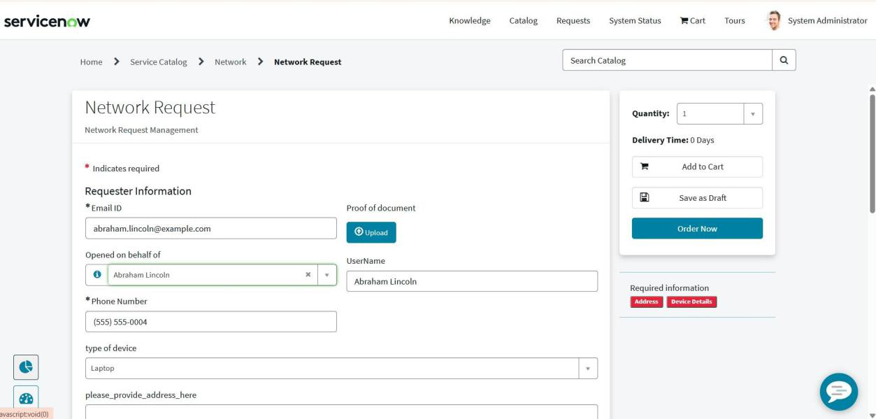
Figure 6.1: Catalog Item configuration
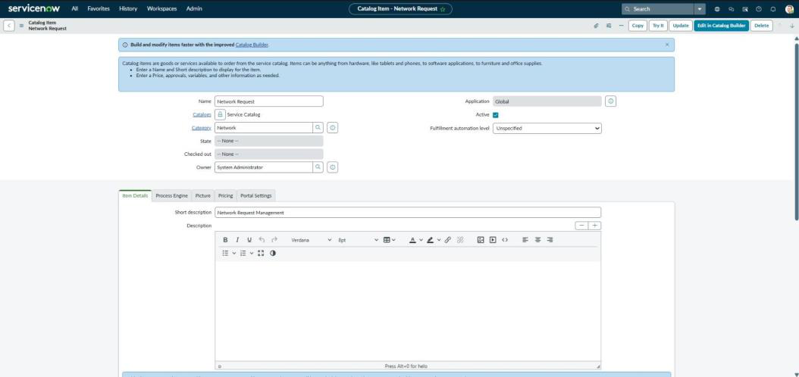
Figure 6.2: Catalog variable configuration

7. Service Portal Interface and Usability
The Service Portal provides the user-facing interface for submitting network requests. Users open the Network Request Catalog Item, enter the required information, and submit the form.
A structured catalog form helps guide users through the information required for processing. Clear labels, appropriate mandatory fields, and a logical field sequence can reduce incomplete submissions and improve usability.

User interaction sequence
- Open the Service Portal.
- Locate and open the Network Request Catalog Item.
- Enter the requested network information.
- Review the information entered in the form.
- Submit the request and retain the generated request reference for tracking.
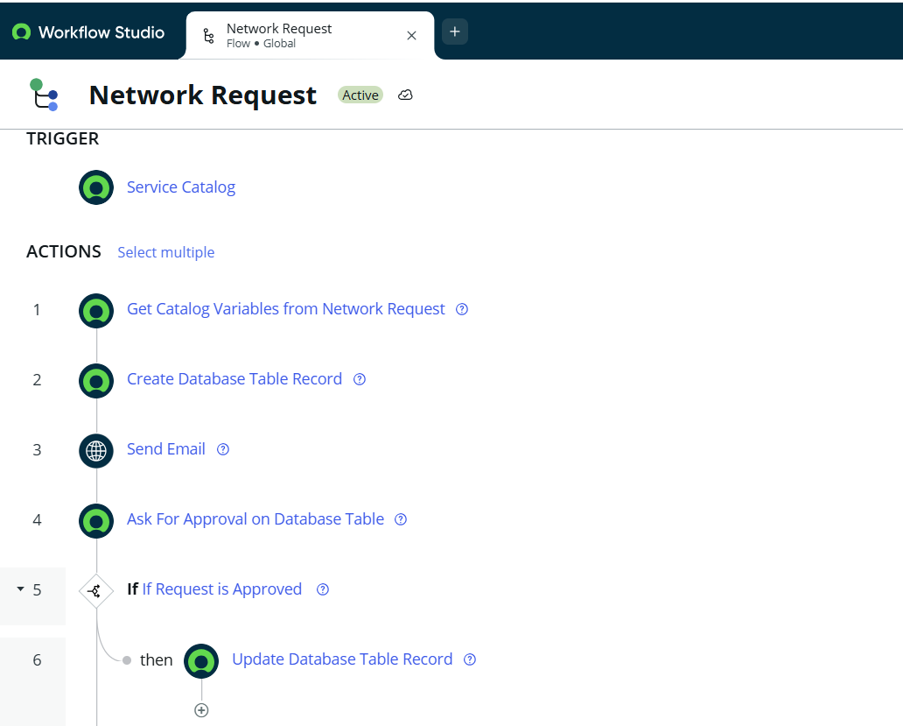
Figure 7.1: Service Catalog configuration evidence
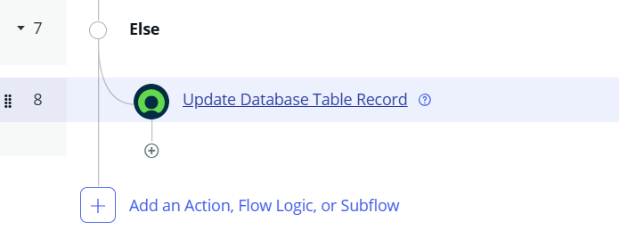
Figure 7.2: Network Request form in the Service Portal

8. Flow Designer Automation
Flow Designer is used to coordinate the automated steps that follow submission of the Network Request Catalog Item. The documented flow is triggered by Service Catalog submission and includes actions to retrieve catalog variables, create a Network Database record, send an email, and request approval.

Documented workflow sequence
Catalog Submission → Retrieve Variables → Create Network Database Record → Approval → Update Record / Continue Workflow
The flow includes a conditional approval branch. The approved path updates the relevant database record and supports subsequent fulfilment through a Network Task. The alternate branch also updates the record; the precise rejection-state value and subsequent handling should be confirmed against the configured flow.

Why Flow Designer is used
- Coordinates multiple workflow actions in a visual sequence.
- Reduces the need for manual hand-offs between request stages.
- Makes approval conditions and workflow paths easier to review.
- Supports consistent processing of submitted catalog requests.
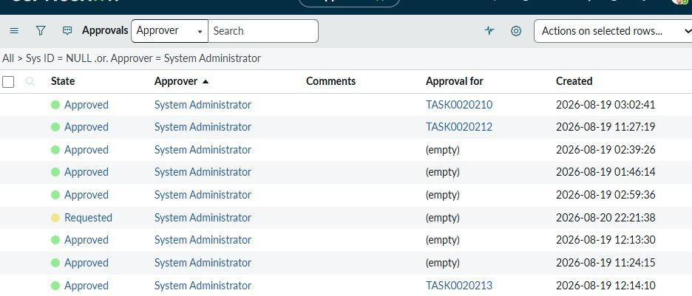
Figure 8.1: Network Request Flow Designer configuration

9. Approvals and Network Task Management
After the Network Database record is created, the request is routed for approval. The approver reviews the submitted request and records an approval decision.

Approval and fulfilment process
- The workflow submits the request for approval.
- The designated approver reviews the request details.
- If approved, the workflow proceeds with fulfilment and creates a Network Task.
- The concerned team uses the task to manage and complete the network request.
- The related request status is updated as the work progresses.
The approval evidence in the original report shows approval records, while the Network Task screenshot demonstrates the task configuration area. These screenshots are retained as implementation evidence.
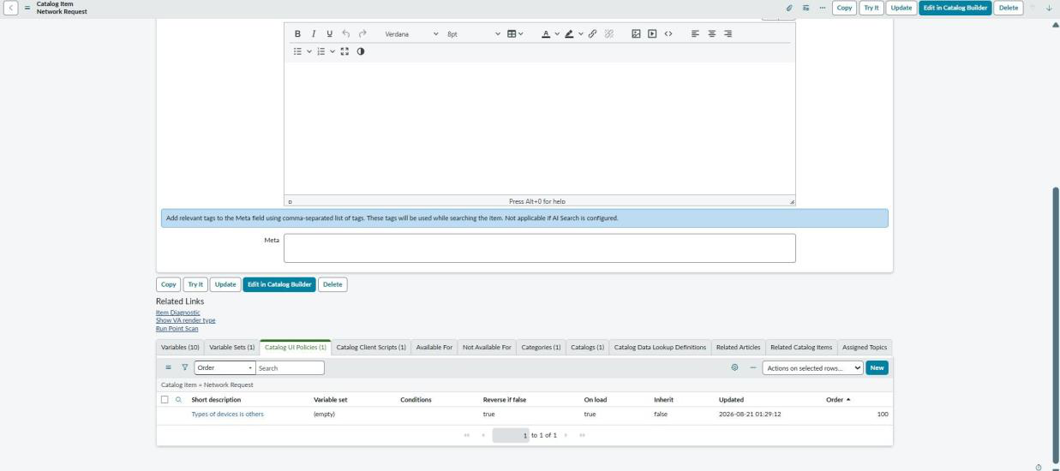
Figure 9.1: Approval records shown in ServiceNow
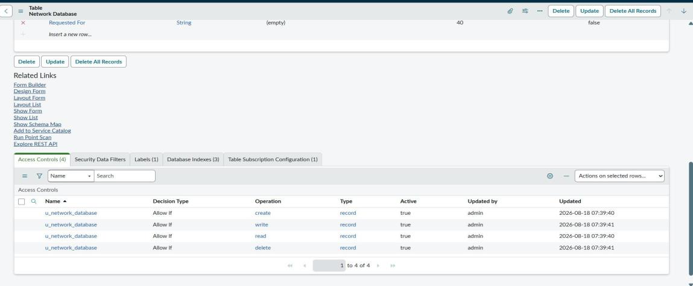
Figure 9.2: Network Task configuration evidence

10. Business Rules, UI Policies, and Access Control
Business Rules, user-interface policies, and Access Control Lists (ACLs) support the behaviour and security of the application.

Configuration areas
- Business Rules: Support server-side processing of request- and task-related records. The exact rule names and scripts should be recorded from the configured instance.
- UI Policies: Control form behaviour, such as field visibility, mandatory state, or read-only state, according to configured conditions.
- Access Control Lists (ACLs): Define which users or roles can read, create, update, or delete application records and fields, subject to the configured rules.
These controls help maintain consistent data handling and restrict access to authorized users. ACL behaviour should be tested for both permitted and denied access scenarios.
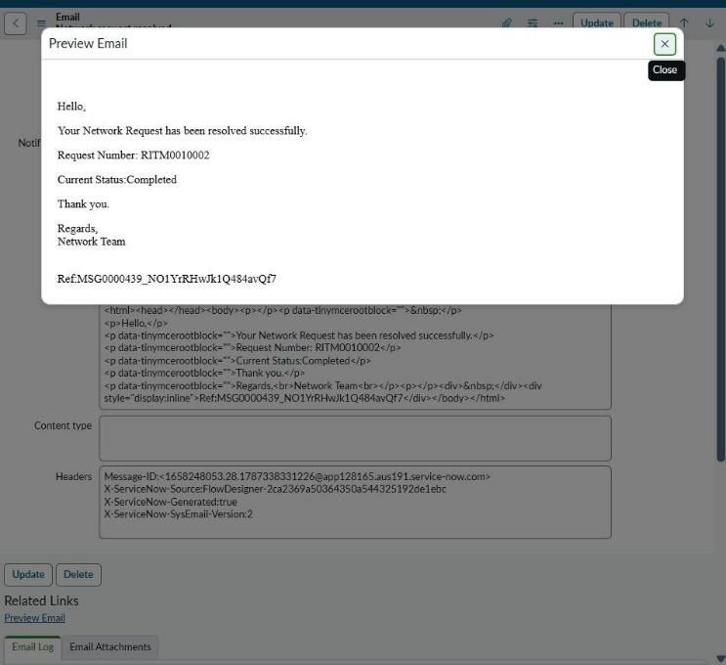
Figure 10.1: UI Policy configuration evidence
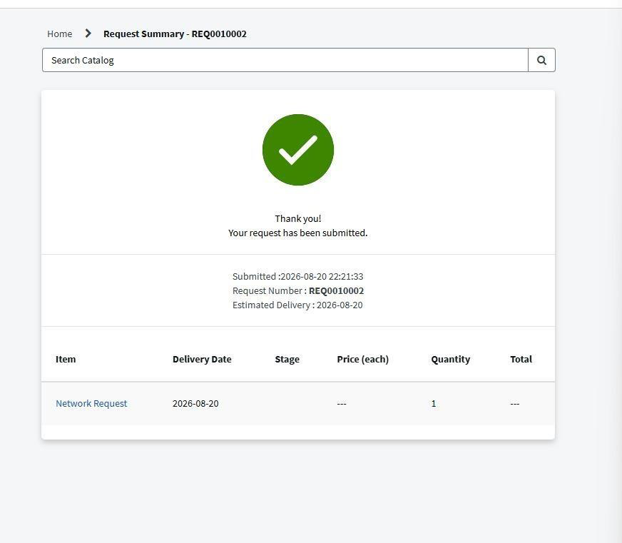
Figure 10.2: ACL configuration evidence

11. Notifications and Status Tracking
The application uses status updates and email notifications to communicate important request events. Notifications help users understand whether their request has been submitted, approved, or progressed towards completion.

Notification and tracking considerations
- Use clear subject lines that identify the request or its reference number.
- Include only relevant request details in the notification body.
- Send notifications to the intended recipients based on the configured event and recipient rules.
- Keep the request status aligned with the actual workflow stage.
- Avoid sending duplicate or misleading notifications.
The source report includes an email notification preview and a request-submission confirmation screen. The exact notification triggers, recipient rules, and status values should be confirmed from the instance configuration.
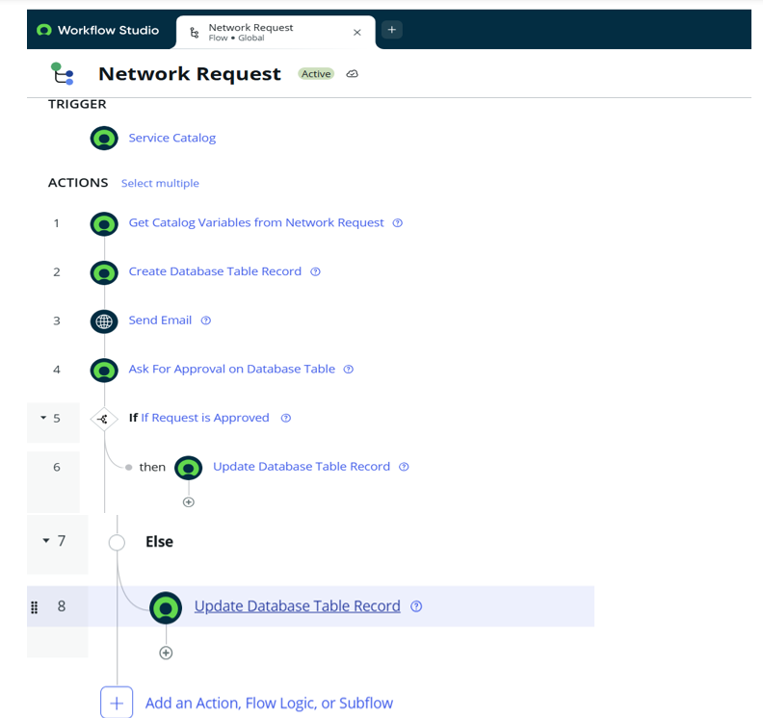
Figure 11.1: Email notification preview

12. End-to-End Functional Workflow
The overall process combines the catalog, standard ServiceNow request records, the custom Network Database record, approval handling, Network Task fulfilment, status updates, and notifications.

End-to-end steps
- A user submits a Network Request through the Service Portal.
- ServiceNow creates the Request and Requested Item records.
- Flow Designer retrieves the catalog variables and creates the Network Database record.
- The request is routed for approval.
- When the request is approved, a Network Task is created for fulfilment.
- The concerned team works on the Network Task.
- The related request status is updated during fulfilment.
- Notifications communicate important updates and completion to relevant users.
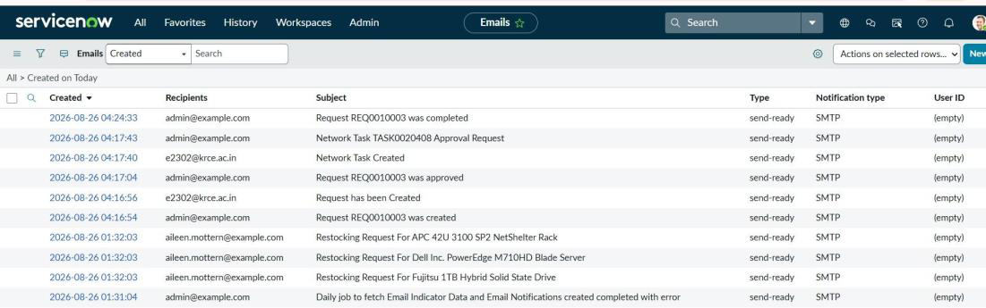
Figure 12.1: Flow Designer workflow used in the project

13. Testing and Validation
The original documentation identifies the following areas as tested or validated. The report does not include a detailed test execution log, individual expected-versus-actual results, or pass/fail evidence for every scenario. The table below organizes the stated validation scope without inventing test outcomes.
Test area | Validation focus
Catalog submission | Confirm that a user can submit the Network Request Catalog Item.
Mandatory fields | Check that required information is enforced before submission.
Requested For | Verify automatic population with the current user.
Standard records | Check creation of Request and Requested Item records.
Network Database | Check creation of the custom Network Database record.
Approval | Verify that the request is routed for approval and the decision is recorded.
Network Task | Verify task creation after approval.
Status tracking | Check that status changes reflect workflow progress.
Notifications | Check that relevant email notifications are generated.
Access control | Verify that authorized access is permitted and restricted access is denied.

Recommended evidence to retain
- Screenshots or record numbers for submitted requests.
- Approval records showing the decision and approver.
- Network Task records linked to the relevant request.
- Email notification previews or received messages.
- ACL test evidence for representative user roles.

14. Deployment and Configuration Management
The project was configured and tested on the ServiceNow platform. The documented implementation includes the catalog item, custom tables, Flow Designer automation, approvals, Network Tasks, notifications, ACLs, and Update Sets.

Deployment considerations
- Review the application configuration before moving changes between instances.
- Use Update Sets to capture and transfer supported configuration changes.
- Confirm that dependent tables, fields, flows, notifications, and access rules are available in the target instance.
- Validate the workflow after deployment, including approval and fulfilment paths.
- Check that notification recipients and access permissions are appropriate for the target environment.
- Retain configuration and test evidence for future maintenance.
The source report refers to Update Sets but does not identify instance names, deployment dates, or a production release record. Those details have therefore not been assumed.

15. Conclusion and Future Enhancements
The Automated Network Request Management application demonstrates how ServiceNow can be used to centralize network request submission and coordinate approval and fulfilment activities. By combining the Service Catalog, Service Portal, Flow Designer, custom tables, approvals, Network Tasks, ACLs, and notifications, the solution provides a structured approach to managing the request lifecycle.
The documented workflow improves process visibility and reduces reliance on manual coordination. Its effectiveness depends on accurate catalog data, correctly configured workflow conditions, appropriate access controls, and reliable status and notification handling.

Future enhancements
- Introduce additional network request categories and configurable approval levels.
- Extend fulfilment automation for recurring or standard network activities.
- Develop dashboards and reports for request volume, approval status, and fulfilment progress.
- Strengthen role-based access and field-level validation where required.
- Enhance portal tracking with clearer progress indicators and request history.
- Maintain a detailed test execution log and operational support guide.

Final note
This report describes the capabilities and configuration areas evidenced in the supplied documentation. Detailed field mappings, custom table technical names, exact ACL roles, approval criteria, and measured test results should be added from the live ServiceNow instance when available.

